1. MAAS, PAAS, Web Services

Difference between Web service and cloud computing

Web hosting is the business of providing server space, web services and file maintenance for websites controlled by companies or individuals that do not have their own web servers and the Cloud computing is a type of computing that relies on sharing computing resources instead of having local servers or personal devices to handle applications.

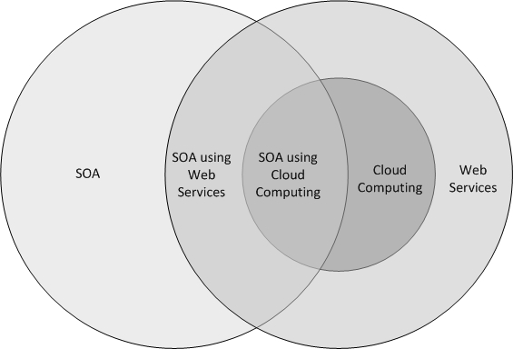

SOA(service-oriented architecture)

Web Services encapsulates Cloud Computing in this diagram because Cloud Computing uses Web Services for connections

Protocol Buffers and Thrift

Protocol buffers are an invention by Google. They're based off RPCs, they're very similar to RPCs. It's a language-neutral, platform-neutral scheme. It's extensible, and what it does is to take the client requests and it serializes it, transmits it to the server. It actually gives the code for the client and they give the code for the server, so just need to know one what want to do, and then the protocol buffer system will actually build for the client, the mechanism to do it, and for the server, the skeletons to actually accomplish the task.

Thrift, allows you to do to is to transmit files between clients and servers, so that one can actually access directly, distributed file systems. It would deal with single-threaded, event-driven servers, that's its specialty. It would deal with processes.

→Load Balancer

A load balancer is a device that acts as a reverse proxy and distributes network or application traffic across a number of servers. Load balancers are used to increase capacity (concurrent users) and reliability of applications.

→ HTTP SOAP REST

Simple Object Access Protocol (SOAP) is a standards-based Web services access protocol that has been around for a while and enjoys all of the benefits of long-term use. Originally developed by Microsoft.

Microsoft originally developed SOAP to take the place of older technologies that don’t work well on the Internet such as the Distributed Component Object Model (DCOM) and Common Object Request Broker Architecture (CORBA). These technologies fail because they rely on binary messaging; the XML messaging that SOAP employs works better over the Internet.

→ CORBA

The Common Object Request Broker Architecture (CORBA) is a specification developed by the Object Management Group (OMG). CORBA describes a messaging mechanism by which objects distributed over a network can communicate with each other irrespective of the platform and language used to develop those objects.

CORBA enables communication between software written in different languages and running on different computers.

→ MBaaS

Mobile backend as a service (MBaaS), also known as "backend as a service" (BaaS), is a model for providing web app and mobile app developers with a way to link their applications to backend cloud storage and APIs exposed by back end applications while also providing features such as user management, push notifications, and integration with social networking services.

BaaS providers form a bridge between the frontend of an application and various cloud-based backends via a unified API and SDK.

Although similar to other cloud-computing developer tools, such as software as a service (SaaS), infrastructure as a service (IaaS), and platform as a service (PaaS), BaaS is distinct from these other services in that it specifically addresses the cloud-computing needs of web and mobile app developers by providing a unified means of connecting their apps to cloud services.

RMI → RMI (Remote Method Invocation) is an API that provides a mechanism to create distributed application in java. The RMI allows an object to invoke methods on an object running in another JVM.

RPC → Remote Procedure Call (RPC) is a protocol that one program can use to request a service from a program located in another computer on a network without having to understand the network's details.

JSON→ JSON stands for JavaScript Object Notation. JSON is a lightweight format for storing and transporting data. JSON is often used when data is sent from a server to a web page.

REST →

REST (REpresentational State Transfer) is an architectural style for developing web services. Create, Update, Read, and Remove objects over the web

→ MAAS

MAAS is Metal As A Service. It lets you treat physical servers like virtual machines (instances) in the cloud. Rather than having to manage each server individually, MAAS turns your bare metal into an elastic cloud-like resource.

→ Juju

Juju is an open source modelling tool for operating software in the cloud. Juju allows you to deploy, configure, manage, maintain, and scale cloud applications quickly and efficiently on public clouds, as well as on physical servers, OpenStack, and containers.

With Juju, one can deploy, configure, scale, and operate your software on public and private clouds. In so doing, Juju creates machines in the cloud you've chosen to use. One such machine, the controller, acts as the central management node for that cloud.

"marshalling" refers to the process of converting the data or the objects into a byte-stream, and "unmarshalling" is the reverse process of converting the byte-stream back to their original data or object. The conversion is achieved through "serialization"

→ XML

Extensible Markup Language is a markup language that defines a set of rules for encoding documents in a format that is both human-readable and machine-readable

SSH (Secure SHell) is a network protocol that allows you to connect to a remote computer (like your Cloud Server) via command-line interface.

IPMI → The Intelligent Platform Management Interface (IPMI) is a remote hardware health monitoring and management system that defines interfaces for use in monitoring the physical health of servers.

It is a set of computer interface specifications for an autonomous computer subsystem that provides management and monitoring capabilities independently of the host system's CPU, firmware (BIOS or UEFI) and operating system.

PXE(Pre-Boot Execution Environment. Pronounced pixie) → It allows computers to boot up remotely through a network interface. PXE enables a client machine to boot from a server independent of the hard disks and installed operating system.

→ AWS Lambda

AWS Lambda is an event-driven, serverless computing platform provided by Amazon as a part of the Amazon Web Services. It is a computing service that runs code in response to events and automatically manages the computing resources required by that code.